Software Requirements Specification

for

SoftUni Blog

Persimmon QA Team

Prepared by Nury Igusty

version 1.1

1.06.2017

Table of Content

1 Introduction 4

1.1 Purpose 4

1.2 Scope 4

1.3 Intended Audience and Reading Suggestions 4

1.4 Product Scope 4

1.5 References 4

2 Overall Description 5

2.1 Product perspective 5

2.2 Product functions 5

2.3 Operating Environment 5

2.4 Design and Implementation Constraints 5

3 Specific requirements 6

3.1 External Interface Requirements 6

3.2 User Interfaces 6

3.3 Hardware Interfaces 10

3.4 Software Interfaces 10

3.5 Communications interfaces 10

4 Performance Requirement 10

Revision History

|  |  |  |  |
| --- | --- | --- | --- |
| **Name** | **Date** | **Reason for Changes** | **Version** |
| Nury Igusty | 01.05.2017 | Version updated | 1.0 |
| Nury Igusty | 01.06.2017 | Version updated | 1.1 |

# **Introduction**

This section gives a scope description and overview of everything included in this SRS document.

## Purpose

The purpose of this document is to give a detailed description of the requirements for the SoftUni Blog System. It will illustrate the purpose and complete declaration for the development of system. It will also explain system constraints, interface and interactions with other external applications.

## Scope

The SoftUni Blog System is web base application which provide administrator and users to managing own articles in the blog seamlessly.

## Intended Audience and Reading Suggestions

This document is primarily intended to be proposed to a customer for its approval and a reference for developing the first version of the system for the development and QA teams.

## Product Scope

The product’s scope:

* Registering and login users;
* Creating, editing and deleting articles;
* Reviewing dashboard;

## References

The documentation refers to Github repo:

<https://github.com/xsaraPN/Blog-Skeleton-TeamProject>

# Overall Description

This section will give an overview of the whole system. The system will be explained in its context to show how the system interacts with other systems and introduce the basic functionality of it.

## Product perspective

This system will represent blog portal. The web portal will be used for managing users and articles as one whole.

## Product functions

The system will provide functionality to manage users and articles:

* Registering new users – If user wants to create an article he/she must be registered. Unregistered user cannot manage articles, only can read them.
* Logging existing users - User logins to the system by entering valid user id and password;
* Creating articles – User can create articles, if he is already logging in the system;
* Editing Articles - User can edit only his own articles;
* Deleting Articles - User can delete only his own articles;
* Dashboard – All users can read all articles;

## Operating Environment

Operating environment for the SoftUni blog must operate with different operating system and Browser versions.

## Design and Implementation Constraints

* SQL Server LocalDB 2016
* operating system: windows 7, 10
* MVC
* QA tools: Selenium WebDriver
* Framework: C#, TeamCity
* GitHub

# Specific requirements

This section contains all of the functional and quality requirements of the system. It gives a detailed description of the system and all its features.

## External Interface Requirements

This section provides a detailed description of all inputs into and outputs from the system. It also gives a description of the hardware, software and communication interfaces and provides basic prototypes of the user interface.

## User Interfaces

A first-time user of the blog portal should see dashboard page, see Figure 1

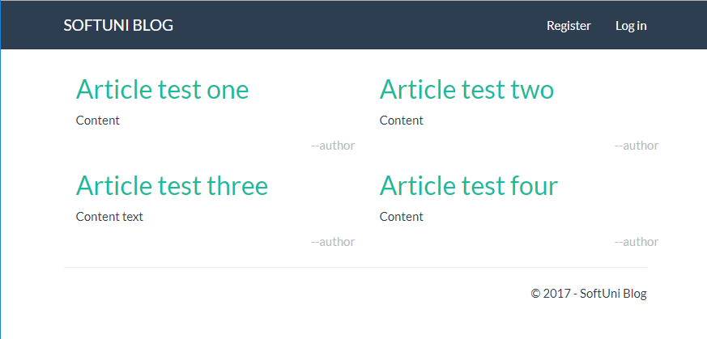

Figure 1 – Dashboard page

Standard links that should appear on this screen are: register link and login link;

If the user has not registered, he/she should be able to do that on the registeration page, see Figure 2

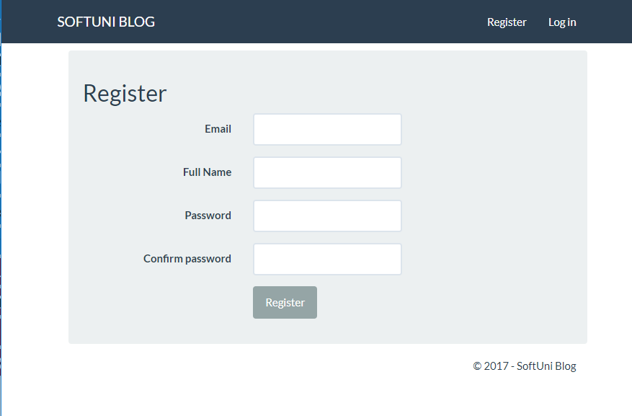

Figure 2 – Register page

Standard links and buttons that should appear on this screen are: Register link, Login link and Resister button;

Every registered user should login in login page (Figure 3).

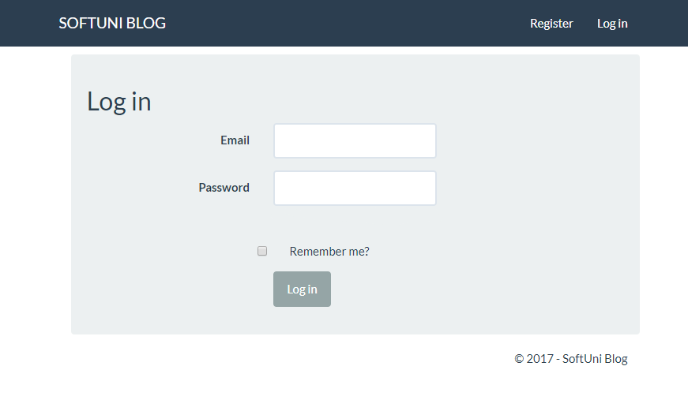

Figure 3 – Login Page

Standard links and buttons that should appear on this screen are: Register link, Login link and Login button;

He/she should be able to create, edit and delete his own articles. see Figure 4, Figure 5, Figure 6.

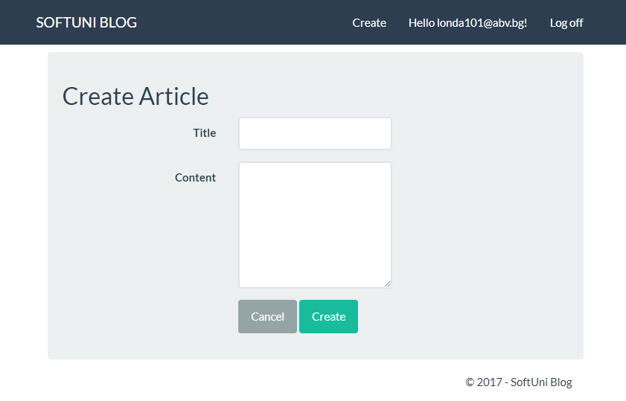

Figure 4 – Create page

Standard links and buttons that should appear on this screen are: Create link, Logoff link, Cancel and Create buttons;

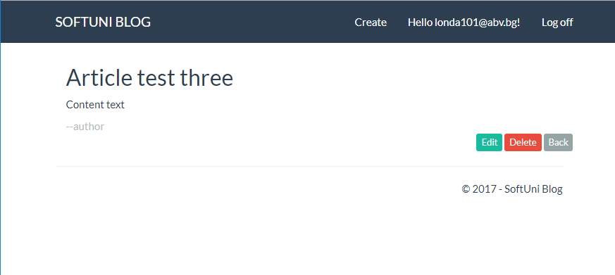

Figure 4 – View article page

Standard links and buttons that should appear on this screen are: Create link, Logoff link, Edit, Delete and Back buttons;

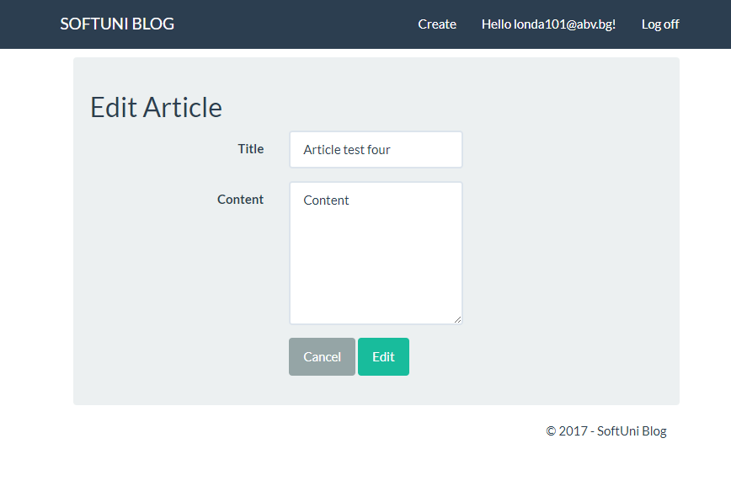

Figure 4 – Edit page

Standard links and buttons that should appear on this screen are: Create link, Logoff link, Cancel and Edit buttons;

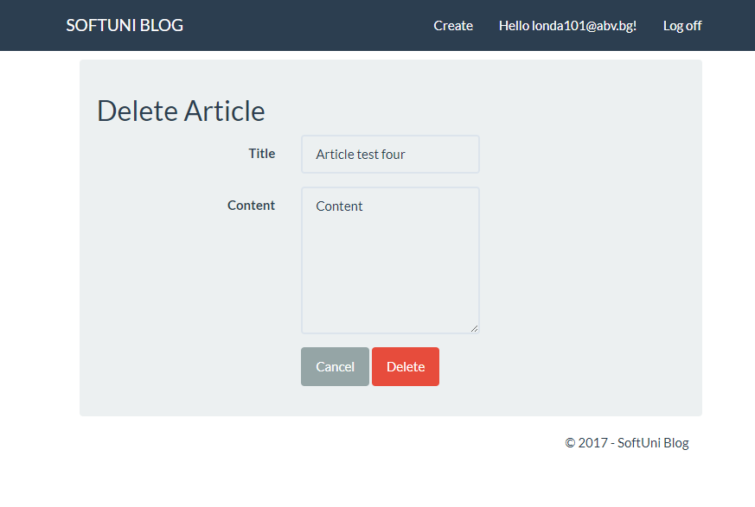

Figure 4 – Delete page

Standard links and buttons that should appear on this screen are: Create link, Logoff link, Cancel and Delete buttons;

## Hardware Interfaces

The blog web portal does not have any designated hardware, it does not have any direct hardware interfaces.

## Software Interfaces

The communication between the database and the web portal consists of operation concerning both reading and modifying the data.

## Communications interfaces

The communication between the different parts of the system is important since they depend on each other.

# Performance Requirement

There is no performance requirement in this system because the server request and response is depended on the end user internet connection.